**Backup for MongoDB using Jenkins**

**Contents**

To BackUp the data-: 3

To restore the data-: 6

# **To BackUp the data-:**

Step 1-: Create Database in mongoDB.

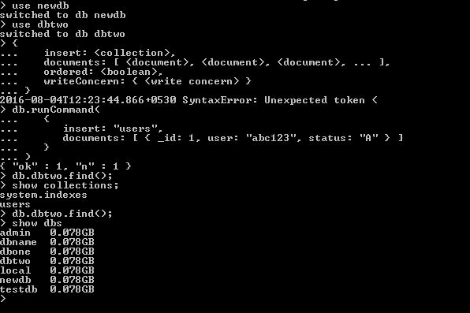

Step 2-: Using **show dbs** we can locate all the databases available in mongoDB.



Step 3-: You can select the directory where you want to create the databse backup, using **Custom Workspace.**

In Directory, select the directory where you want to create backup.

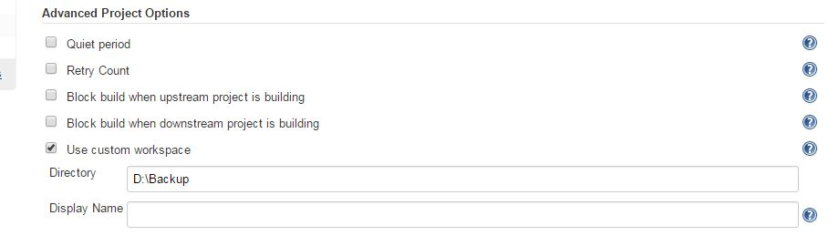

Step 4-: To get the backup of the database of mongoDB from Jenkins, we need to run mongodb.exe file through **Execute windows batch command** in Jenkins.

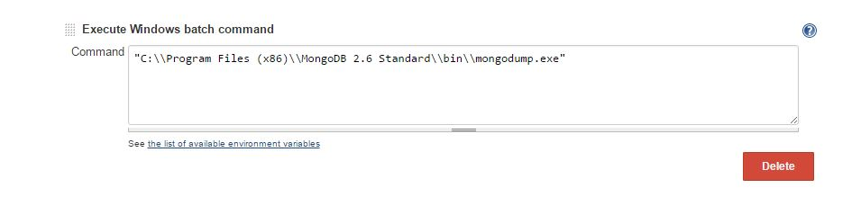

Step 5-: The database of your mongoDB is backup in selected workspace(D:/backup).

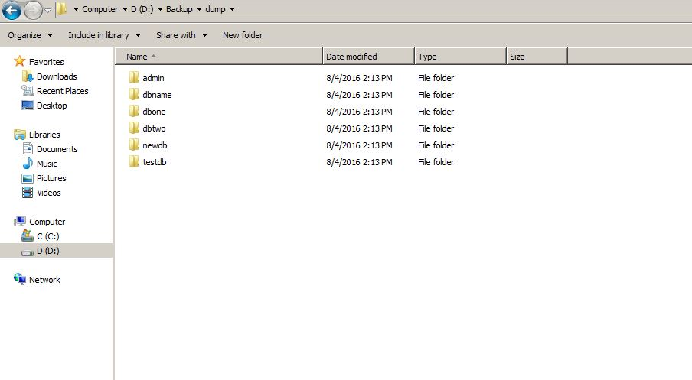

## **To restore the data-:**

Step 1-: Drop the database from mongoDB.

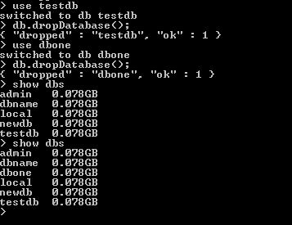

Step2-: Run the **Execute windows batch command** for mongorestore.

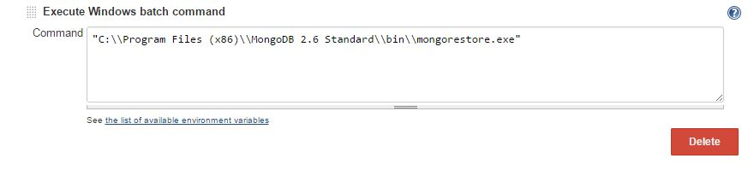

Step 3-: After building this job you can find the dropped databse “dbone” is restored.

